# 717821D156 – Sukuna D

**WEEK3**

**Miniproject:**

**Task Manager:**

<!DOCTYPE html>

<html lang="en">

<head>

<meta charset="UTF-8">

<meta name="viewport" content="width=device-width, initial-scale=1.0">

<title>Task Manager</title>

</head>

<script>

document.addEventListener('DOMContentLoaded', async () =>

{

await loadTasks(); document.getElementById('addTask').addEventListener('click', addTaskToList); document.getElementById('taskList').addEventListener('click', handleTaskClick);

});

async function loadTasks()

{

let tasks = await getTasksFromStorage();

tasks.forEach(task => displayTask(task));

}

function displayTask(task)

{

let li = document.createElement('li'); li.textContent = task; li.setAttribute('data-task', task);

let deleteBtn = document.createElement('button'); deleteBtn.textContent = 'Delete'; deleteBtn.classList.add('delete'); li.appendChild(deleteBtn);

document.getElementById('taskList').appendChild(li);

}

function handleTaskClick(e)

{

if (e.target.classList.contains('delete'))

{

let task = e.target.parentElement.getAttribute('data-task'); deleteTask(task);

e.target.parentElement.remove();

}

}

async function addTaskToList()

{

let task = document.getElementById('taskInput').value.trim(); if (task)

{

await saveTaskToStorage(task); displayTask(task); document.getElementById('taskInput').value = '';

}

}

async function getTasksFromStorage()

{

let tasks = localStorage.getItem('tasks'); return tasks ? JSON.parse(tasks) : [];

}

async function saveTaskToStorage(task)

{

let tasks = await getTasksFromStorage(); tasks.push(task);

localStorage.setItem('tasks', JSON.stringify(tasks));

}

async function deleteTask(taskToDelete)

{

let tasks = await getTasksFromStorage();

tasks = tasks.filter(task => task !== taskToDelete); localStorage.setItem('tasks', JSON.stringify(tasks));

}

</script>

<body>

<h1>Task Manager</h1>

<input type="text" id="taskInput" placeholder=" Implement your task here...">

<button id="addTask">Add Task</button>

<ul id="taskList"></ul>

<script src="app.js"></script>

</body>

</html>

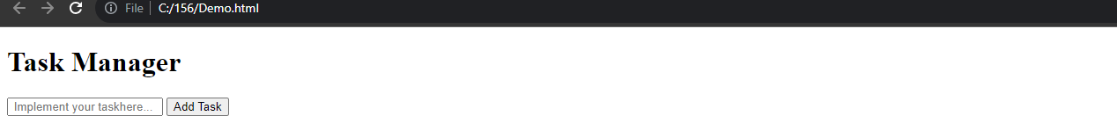**OUTPUT:**

# Repository :

<https://github.com/SukunaDuraisamy/717821D156_JS_Miniproject>